JAVA PROGRAM – OBSERVATION TASK 4
Student Performance Report using Class, Array, String and Math Operations

1. Objective
To develop a Java program using a Student class to store student details and marks, calculate total, average, highest and lowest marks, percentage, grade and pass/fail status, and display a formatted performance report using arrays, methods, String operations, type casting, Math functions, conditional statements and switch-case.

2. Hardware Requirements
- Computer/Laptop
- Minimum 4 GB RAM
- At least 500 MB free storage
- Keyboard and mouse
- Display monitor

3. Software Requirements
- Operating System: Windows / Linux / macOS
- Java Development Kit (JDK 8 or later; JDK 26 is also suitable)
- Java compiler (javac)
- Java Runtime Environment (java)
- IDE/Text editor: VS Code, IntelliJ IDEA, Eclipse, or any text editor

4. Algorithm
1. Start the program.
2. Create a Scanner object to read input from the user.
3. Read the student's roll number and name.
4. Set the number of subjects to 5 and create an integer array to store marks.
5. Read marks for all five subjects.
6. Create a Student object using the roll number, name and marks.
7. Calculate total marks by adding all subject marks.
8. Calculate average using total marks divided by number of subjects, with type casting to double.
9. Find the highest mark using Math.max() and the lowest mark using Math.min().
10. Calculate percentage using total marks divided by maximum total marks and multiply by 100.
11. Round the percentage to two decimal places using Math.round().
12. Determine the grade using if-else conditions.
13. Determine PASS/FAIL using the percentage.
14. Generate a performance remark using switch-case.
15. Format the student name using trim(), toUpperCase() and length().
16. Display the complete student performance report.
17. Close the Scanner and stop the program.

5. UML Class Diagram
+----------------------------------------------+
| Student |
+----------------------------------------------+
| - rollNumber : int |
| - name : String |
| - marks : int[] |
| - numSubjects : final int |
| - maxMarksPerSubject : final int = 100 |
+----------------------------------------------+
| + Student(int, String, int[]) |
| + calculateTotal() : int |
| + calculateAverage() : double |
| + findHighest() : int |
| + findLowest() : int |
| + calculatePercentage() : double |
| + getRoundedPercentage() : double |
| + determineGrade() : String |
| + hasPassed() : boolean |
| + getPerformanceRemark() : String |
| + getFormattedName() : String |
| + displayReport() : void |
+----------------------------------------------+
creates
|
v
+----------------------------------------------+
| ObservationTask4 |
+----------------------------------------------+
| + main(String[]) : void |
+----------------------------------------------+

6. Program
import java.util.Scanner;
class Student {
private int rollNumber;
private String name;
private int[] marks;
private final int numSubjects;
private final int maxMarksPerSubject = 100;
public Student(int rollNumber, String name, int[] marks) {
this.rollNumber = rollNumber;
this.name = name;
this.marks = marks;
this.numSubjects = marks.length;
}
public int calculateTotal() {
int total = 0;
for (int i = 0; i < numSubjects; i++) {
total += marks[i];
}
return total;
}
public double calculateAverage() {
return (double) calculateTotal() / numSubjects;
}
public int findHighest() {
int highest = marks[0];
for (int i = 1; i < numSubjects; i++)
highest = Math.max(highest, marks[i]);
return highest;
}
public int findLowest() {
int lowest = marks[0];
for (int i = 1; i < numSubjects; i++)
lowest = Math.min(lowest, marks[i]);
return lowest;
}
public double calculatePercentage() {
int maxTotal = numSubjects * maxMarksPerSubject;
return ((double) calculateTotal() / maxTotal) * 100;
}
public double getRoundedPercentage() {
double percentage = calculatePercentage();
return Math.round(percentage * 100.0) / 100.0;
}
public String determineGrade() {
double percentage = calculatePercentage();
if (percentage >= 90) return "A+";
else if (percentage >= 80) return "A";
else if (percentage >= 70) return "B";
else if (percentage >= 60) return "C";
else if (percentage >= 50) return "D";
else return "F (Fail)";
}
public boolean hasPassed() {
return calculatePercentage() >= 50;
}
public String getPerformanceRemark() {
String grade = determineGrade();
switch (grade) {
case "A+": return "Outstanding performance! Keep up the excellent work.";
case "A": return "Excellent performance!";
case "B": return "Good performance. Room for improvement.";
case "C": return "Average performance. Needs more effort.";
case "D": return "Below average. Needs significant improvement.";
default: return "Failed. Immediate attention and effort required.";
}
}
public String getFormattedName() {
String cleanName = name.trim();
return cleanName.toUpperCase() +
" (Length: " + cleanName.length() + " characters)";
}
public void displayReport() {
System.out.println("\n--- Student Report ---");
System.out.println("Roll Number : " + rollNumber);
System.out.println("Student Name : " + getFormattedName());
System.out.print("Subject Marks : ");
for (int i = 0; i < numSubjects; i++) {
System.out.print(marks[i]);
if (i != numSubjects - 1) System.out.print(", ");
}
System.out.println();
System.out.println("Total Marks : " + calculateTotal() + " / " +
(numSubjects * maxMarksPerSubject));
System.out.println("Average Marks : " +
String.format("%.2f", calculateAverage()));
System.out.println("Highest Marks : " + findHighest());
System.out.println("Lowest Marks : " + findLowest());
System.out.println("Percentage : " + getRoundedPercentage() + "%");
System.out.println("Grade : " + determineGrade());
System.out.println("Result : " + (hasPassed() ? "PASS" : "FAIL"));
System.out.println("Remark : " + getPerformanceRemark());
}
}
public class ObservationTask4 {
public static void main(String[] args) {
Scanner sc = new Scanner(System.in);
System.out.print("Enter Roll Number: ");
int rollNumber = Integer.parseInt(sc.nextLine().trim());
System.out.print("Enter Student Name: ");
String name = sc.nextLine();
int numSubjects = 5;
int[] marks = new int[numSubjects];
System.out.println("Enter marks for " + numSubjects +
" subjects (out of 100 each):");
for (int i = 0; i < numSubjects; i++) {
System.out.print("Subject " + (i + 1) + ": ");
marks[i] = Integer.parseInt(sc.nextLine().trim());
}
Student student = new Student(rollNumber, name, marks);
student.displayReport();
sc.close();
}
}

7. Compilation and Execution Steps
1. Save the program with the exact file name ObservationTask4.java because the public class is ObservationTask4.
2. Open Command Prompt/Terminal and navigate to the folder containing the file.
3. Compile the program using: javac ObservationTask4.java
4. If there are no compilation errors, a class file is generated.
5. Run the program using: java ObservationTask4
6. Enter the roll number, student name and marks for five subjects when prompted.
7. Observe the calculated student performance report.

8. Commands
javac ObservationTask4.java
java ObservationTask4

9. Sample Output
The following is a sample execution using Roll Number 244, name Hemanth Kumar and marks 95, 88, 91, 84 and 90.
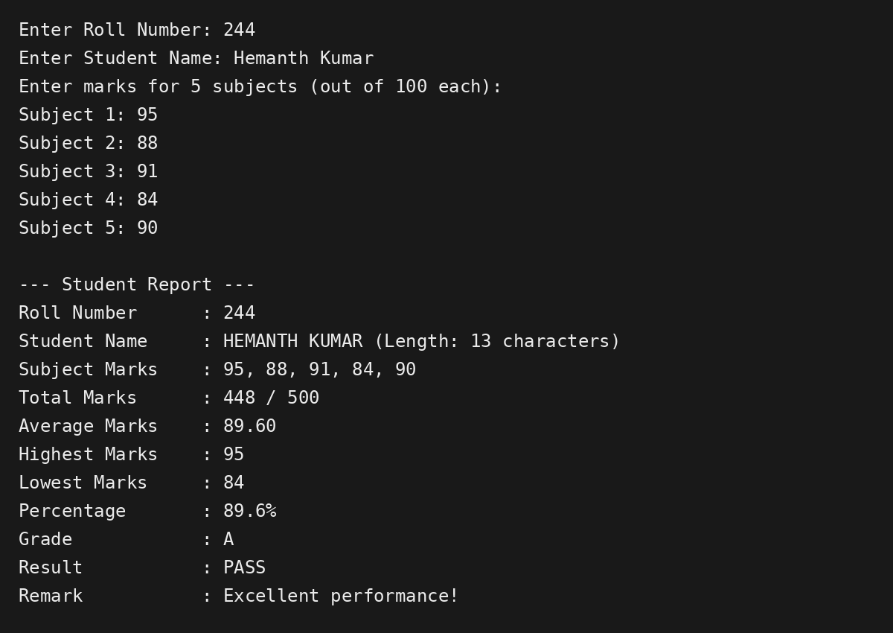
Figure: Sample terminal output for ObservationTask4

10. Result
The Java program was successfully designed and executed to calculate and display a student's total marks, average, highest and lowest marks, percentage, grade, result and performance remark. The program also demonstrates encapsulation, arrays, methods, type casting, String operations, Math functions, if-else and switch-case statements.

